**Marketing Guide**

## Background:

Healthcare costs continue to rise at an alarming rate, particularly in the United States. This issue presents a major challenge for patients, healthcare and pharmaceutical industries. Kaiser Pamanente (KP), a leading healthcare provider in the US, wants to explore preventative solutions through technological innovations. This is an approach that promotes healthy habits, which in return, reduce and possibly eliminates the development of chronic disease, coupled with reduction in cost of diagnosis and treatment of such illness.

Chronic disease such as Diabetes is affecting quality of lives significantly across age categories. It is a disease that causes damage to large blood vessels of the heart, brain and legs. Also, to small blood vessels, causing problems in the eyes, kidneys, feet and nerves (macrovascular complications). Due to the nature of the disease and how widely spread in the society, the cost of diagnosis and treatment is increasingly high. Healthcare and pharmaceutical industries are faced with uncontrollable costs, projecting 26% increase over a five year period. According to healthcare statistics, about 33 percent of American adults could have diabetes by the year 2050. Americans will spend $3.65 trillion on health, which amounts to 17.8% of the country’s GDP. The estimated average cost of healthcare in a year is about $10, 300 per person.

The most viable and cost effective preventative approach to reducing and possibly eliminating this staggering cost problem is through controlled healthy habits. This can be achieved with Healthy Living Partner, a mobile app that monitors glucose level, tracks and recommend daily diets, along with appropriate routine exercise activities. The user gets to have total control of daily diets and exercise habits, which will enhance healthy lifestyle. With proper use of this app, the development of chronic disease can be controlled and eliminated, thereby allowing healthcare providers to save significantly on costs to diagnose and treat less severe cases.

## Market background:

Target Audience

Healthy Living Partner App is designed for adults within 45 to 75 years of age. In particular, anyone that is health conscious, including those that are under healthcare programs for chronic disease. The highest number of diabetes cases is known to be the highest among this age group or category. An ideal customer or user will be someone with Type_2 Diabetes or similar type of chronic disease, as well as, anyone interested in adopting healthy lifestyle habits.

Target Market

This app fits into a variety of markets. Specifically, healthcare, wellness and fitness segments of a broad market much to the fact that it combines healthy diet options, wellness activity resources along with monitoring and performance capabilities, thereby serving as a conduit to preventing diabetes or other chronic illness.

The goal is to roll the product out to individual users, collaborate with healthcare providers and health insurance sales distribution channels.

Competition

Momentum by Apple/Maehlum and Habitbull by Appholdings are some of the competitions. The core strength of these products is centered on training the human system to add or drop habits. While the competition’s main focus is on boosting the will power and training human system on habits, the Healthy Living Partner incorporates Glucose or Blood Sugar-level Monitor, bundled with Activity Mate and API, thereby providing the user with a wide range of control of key components of healthy living.

This solution offers a win-win environment for patients, healthcare providers, pharmaceuticals and the society in general. Healthcare can be truly affordable if we can live healthier.

## Product Background and Positioning:

For wellness and healthy lifestyle enthusiasts that want to take advantage of state- of-the-art apps that offer easy and convenient access to preventative monitored diet and exercise routine, Healthy Living Partner is the one-stop-shop app for healthy lifestyle habits anywhere at any time. It combines all the essential components of health and wellness into one.

Features

1. Diet Assistant - Provides the user with a healthy diet list for Breakfast, Lunch and Dinner, including options for recommended diet combination. Users can select and follow guidance.
2. Exercise Activity Mate - Offer users a wide variety of exercise activities specifically tailored for ensuring adequate blood flow and burning calories, thereby allowing d proper body weight maintenance.
3. Glucose Monitor - The feature is a critical piece that allows users to keep track of the blood sugar-level, including threshold crossing notification capability.
4. Performance Monitor
5. API - The Application Programming Interface provides a flexible means of integration with other products to access or transfer data.

The Healthy Living Partner mobile app

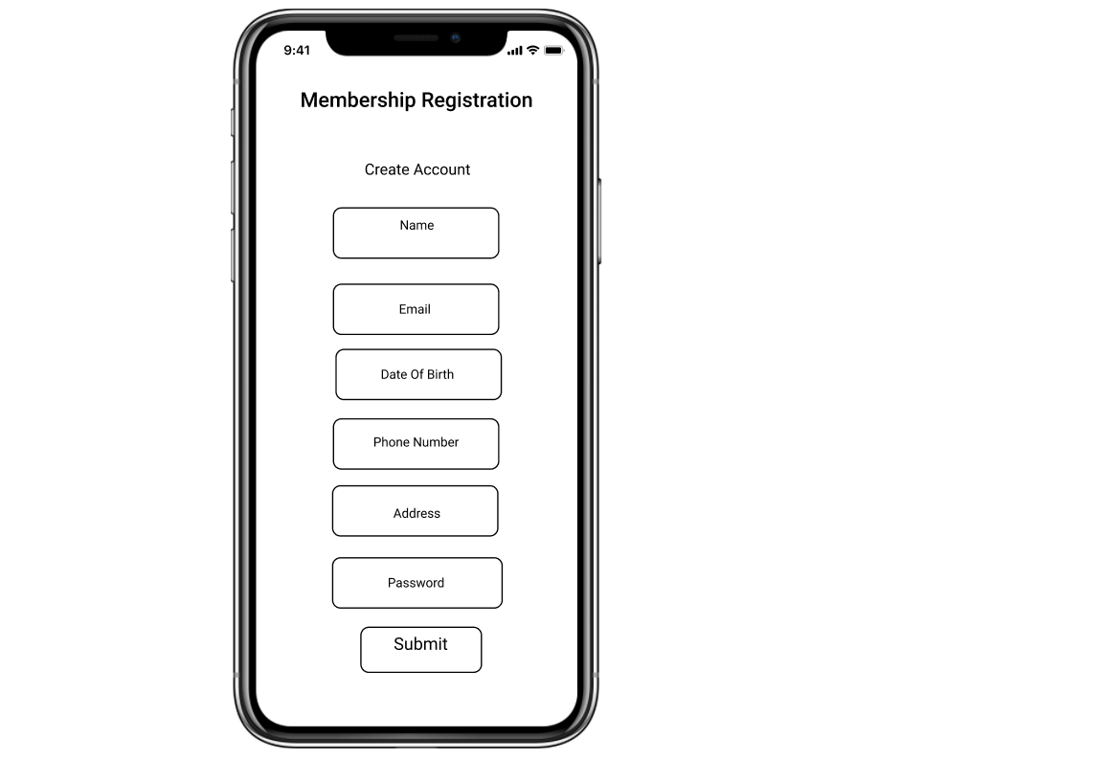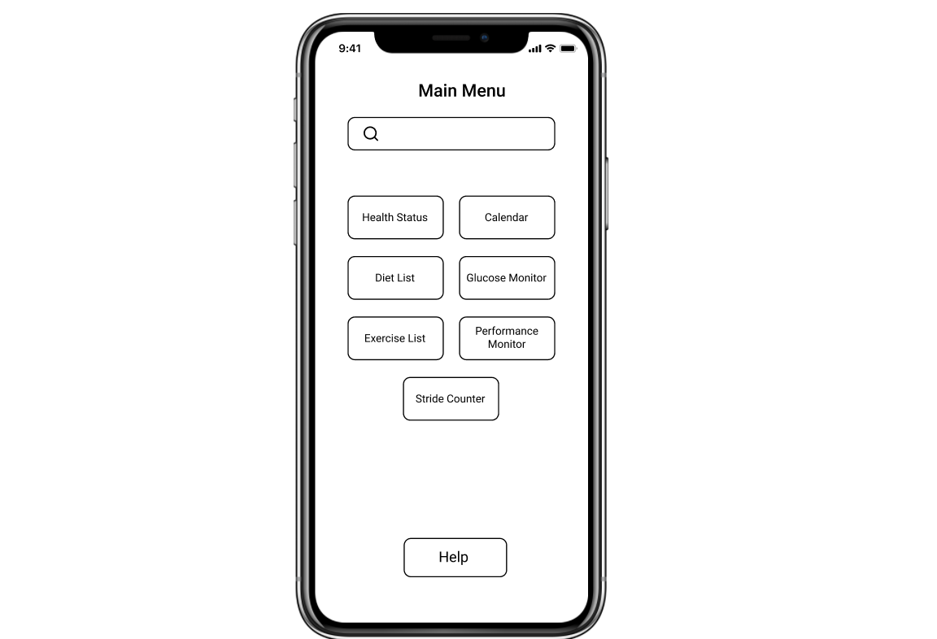

[Prototype Link: Healthy Living Partner](https://www.figma.com/proto/jWkYF0Wsq68aAYEP54olw6/Healthy-Living-Partner-(New)?node-id=7%3A0&viewport=502%2C233%2C0.2484641671180725&scaling=scale-down)